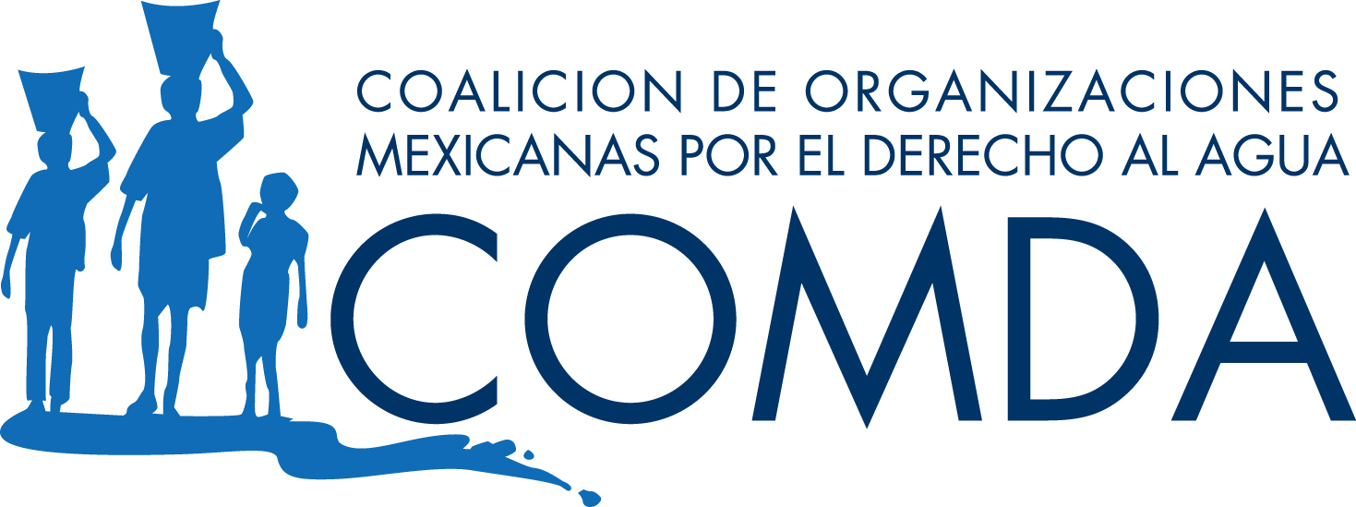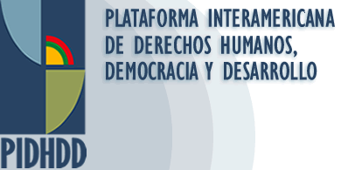

April 2, 2008 CONTACTS
Mexico City Astrid Puentes, +(52555) 5212-0141, apuentes@aida-americas.org
Claudia Gómez-Portugal, +(5255) 8995-7920 claudia@sakbe.com
Noé Pineda Arredondo, +(5255) 5512-1586 comunicacion@hic-al.org

The Collegiate Tribunal of Guerrero in Acapulco receives Amicus Curiae
in support of a constitutional lawsuit against the La Parota dam

Mexican and international human rights organizations presented an Amicus Curiae on March 27th, in defense of affected people’s rights and the environment

Mexican and international organizations submitted an Amicus Curiae to the Collegiate Tribunal of Guerrero in Acapulco in support of a constitutional lawsuit brought by CECOP and the Mexican Center for Environmental Law against the Federal Commission of Electricity (CFE) and other authorities. The lawsuit alleges that the Mexican authorities failed to consult with affected parties and adequately evaluate the environmental impacts of construction of the La Parota dam. “We are confident that as the Tribunal evaluates this case of great importance to Mexico, it will also consider international law, which offers many opportunities to fill in missing areas in national legislation,” said Alicia Carriquiriborde of FIAN.
The nearly twenty organizations that signed the letter argue that approval of the hydroelectric project disregards national as well as international human rights and environmental laws, including those that protect the rights to a fair trial and economic, social and environmental rights such as the rights to housing, a clean environment, food, and health.
In addition, the letter is supported by the Report of the United Nations Special Rapporteurs, Rodolfo Stavenhagen (regarding the Rights of Indigenous People) and Miloon Kothari (regarding the Right to Adequate Housing). During the beginning of March, before the United Nations Council on Human Rights, they requested that the Mexican government, “not having completely satisfied the questions that have been raised [in the UN report] or having given all of the guarantees that human rights of the affected people will be respected, or having seriously analyzed all of the possible alternatives, suspend work on the Hydroelectric Project.” Among the project’s major flaws are lack of information provided to those affected by the dam and gaps in the comprehensive environmental impact study that evaluates damages the dam will cause, measures to prevent impacts, as well as possible alternatives to the project.
Considering these flaws and the human rights violations of people affected by the La Parota megaproject, we appeal to the Collegiate Tribunal of Guerrero, arguing that it should make use of its power, in the interest of the law and the Pacts and Human Rights Conventions ratified by the Mexican government, and grant the injunction for the residents of La Parota, accept the arguments of the Amicus, and cancel all work related to the construction of the La Parota dam until the Mexican government completely complies with local people’s demands and applicable national and international laws. “The intention of the Amicus is to help strengthen the protection of human rights in this case, based on our experiences in international law,” noted Astrid Puentes of AIDA.
Signed by:
The Interamerican Association for Environmental Defense (AIDA); Coalición de Organizaciones Mexicanas por el Derecho al Agua (COMDA); Espacio DESC: Espacio de Coordinación de Organizaciones Civiles sobre DESC-capítulo mexicano de la Plataforma Interamericana de Derechos Humanos; Democracia y Desarrollo (PIDHDD); Housing and Land Rights Network; Habitat International Coalition; Environmental Defender Law Center (United States); International Rivers (United States); Corporación de Gestión y Derecho Ambiental ECOLEX (Ecuador); and FIAN Internacional (Germany)

The Espacio DESC is comprised of 13 organizations, in alphabetical order: Casa y Ciudad de Coalición Hábitat México, Cátedra UNESCO de Derechos Humanos de la Universidad Nacional Autónoma de México, Centro de Estudios Sociales y Culturales Antonio de Montesinos (CAM), Centro de Derechos Humanos Miguel Agustín Pro Juárez (PRODH), Centro de Reflexión y Acción Laboral (CEREAL) de Fomento Cultural y Educativo, Comisión Mexicana de Defensa y Promoción de los Derechos Humanos (CMDPDH), DECA Equipo Pueblo, Defensoría del Derecho a la Salud – Chiapas, FIAN Sección México, Instituto Mexicano para el Desarrollo Comunitario (IMDEC) –Guadalajara, Liga Mexicana de Defensa de Derechos Humanos (LIMEDDH), Oficina Regional para América Latina y el Caribe de la Coalición Internacional del Hábitat, Radar-Colectivo de estudios Alternativos en Derecho.

